**Lab 10 task**

**Create the following Chatbot (GUI using Flask), develop its "Flask -> HTM:" based front-end**

**-> Library Information**

**Explanation:**

This Flask-based chatbot is a simple web application that provides predefined library information through a user-friendly interface. It uses a dictionary to store responses about common queries like library timings, location, membership, rules, and book borrowing policies. When a user enters a question via the GUI (served through index.html), the message is sent to the Flask backend using a POST request. The server checks for keywords in the user message and returns the appropriate response. If no keyword matches, a default help message is returned. The chatbot runs locally on localhost:5000, making it ideal for lightweight applications or demonstrations.

**Output:**

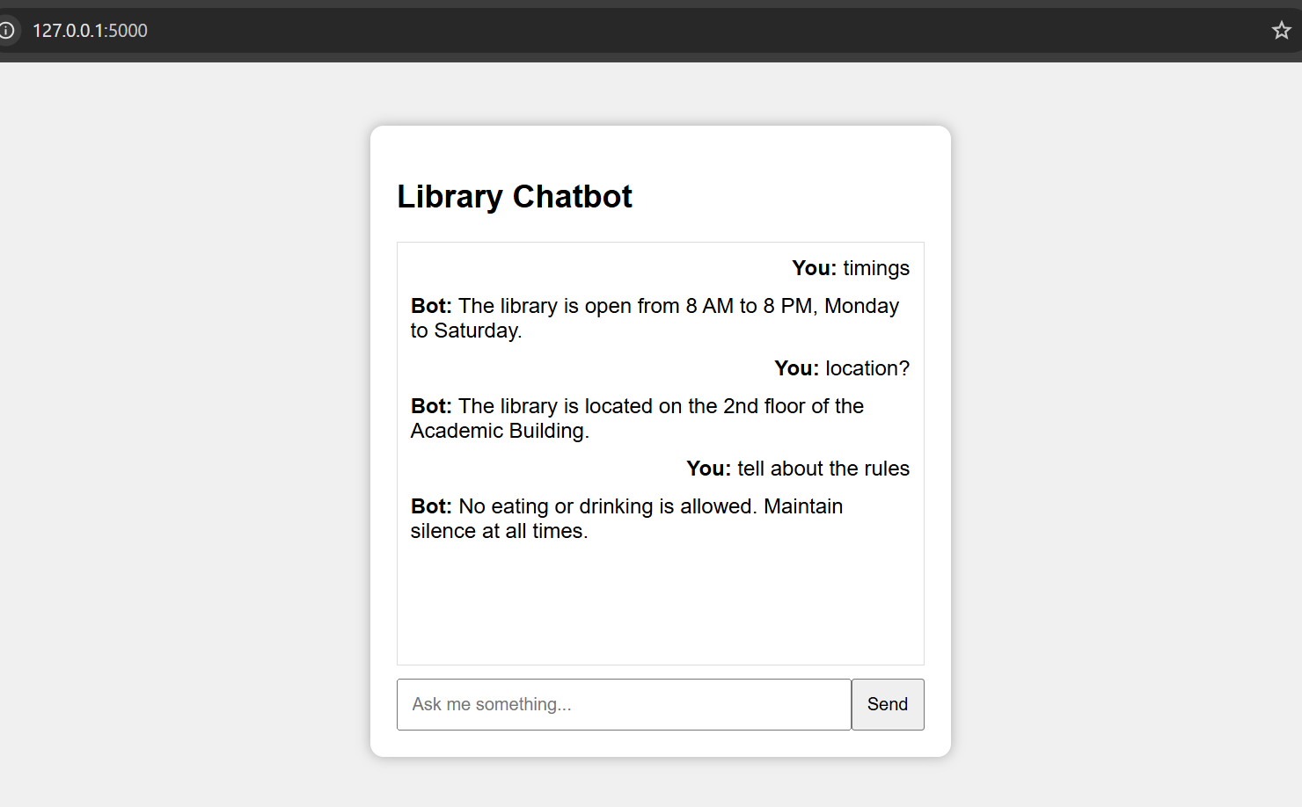

**app.py**

from flask import Flask, render_template, request, jsonify

app = Flask(__name__)

database = {

    "timings":"The library is open from 8 AM to 8 PM, Monday to Saturday.",

    "location":"The library is located on the 2nd floor of the Academic Building.",

    "membership":"To get a membership, fill the registration form at the front desk.",

    "rules":"No eating or drinking is allowed. Maintain silence at all times.",

    "books":"You can borrow up to 3 books for 14 days. Renewals allowed once."

}

@app.route("/")

def home():

    return render_template("index.html")

@app.route("/get", methods=["POST"])

def chatbot_response():

    user_input = request.form["msg"].lower()

    response = "Sorry, I didn't understand that. Try asking about timings, location, membership, rules, or books."

    for key in database:

        if key in user_input:

            response = database[key]

            break

    return jsonify({"response": response})

if __name__ == "__main__":

    app.run(debug=True)

**index.html**

<!DOCTYPE html>

<html>

<head>

    <title>Library Chatbot</title>

    <style>

        body { font-family: Arial, sans-serif; background: #f0f0f0; padding: 40px; }

        .chatbox { width: 400px; margin: auto; background: white; padding: 20px; border-radius: 10px; box-shadow: 0 0 10px #aaa; }

        .messages { height: 300px; overflow-y: auto; border: 1px solid #ddd; padding: 10px; margin-bottom: 10px; }

        .input-area { display: flex; }

        .input-area input { flex: 1; padding: 10px; }

        .input-area button { padding: 10px; }

        .user { text-align: right; margin-bottom: 10px; }

        .bot { text-align: left; margin-bottom: 10px; }

    </style>

</head>

<body>

    <div class="chatbox">

        <h2>Library Chatbot</h2>

        <div class="messages" id="chatbox"></div>

        <div class="input-area">

            <input type="text" id="userInput" placeholder="Ask me something..." autocomplete="off">

            <button onclick="sendMessage()">Send</button>

        </div>

    </div>

    <script>

        function sendMessage() {

            let userMsg = document.getElementById('userInput').value;

            if (!userMsg) return;

            let chatbox = document.getElementById('chatbox');

            chatbox.innerHTML += `<div class='user'><strong>You:</strong> ${userMsg}</div>`;

            document.getElementById('userInput').value = '';

            fetch('/get', {

                method: 'POST',

                headers: { 'Content-Type': 'application/x-www-form-urlencoded' },

                body: 'msg=' + encodeURIComponent(userMsg)

            })

            .then(res => res.json())

            .then(data => {

                chatbox.innerHTML += `<div class='bot'><strong>Bot:</strong> ${data.response}</div>`;

                chatbox.scrollTop = chatbox.scrollHeight;

            });

        }

    </script>

</body>

</html>